Ms. Johnson’s Supply List **2025-2026**

Grade **5**

Richmond Hill Elementary

1. Personal hand sanitizer 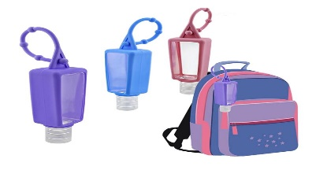
2. **(2)** 1 inch binders
3. **(2)** pks. of blue pens
4. **(2)** pks. of black pens
5. **(6)** **Wide-Ruled** marble composition notebooks
6. **(1)** box of highlighters
7. One zippered pencil bag (**NO** pencil boxes) 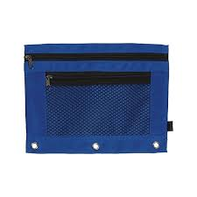
8. 2 pairs of ear phones (one pair for 1st semester and one pair for 2nd semester) 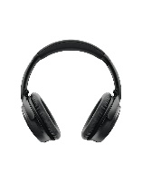

*Wish List

* (1) 2 liter bottle of hand sanitizer
* Clorox or Lysol wipes
* Tissue

\***NO** Pencils or Pencil Sharpeners*